**DIGITAL IMAGE PROCESSING LAB**

**FINAL LAB PAPRT REPORT**

**BSCE-VIII**

**By**

**M Abul Hassan (202101004)**



**Submitted to: Sir Zia ur Rehman**

**Date:** June-11-2024

**DEPARTMENT OF COMPUTER ENGINEERING**

**INSTITUTE OF SPACE TECHNOLOGY**

**KICSIT, KAHUTA CAMPUS**

**Q1:Produce the python program to explore the OpenCV tracker function with an example?**

**Code:**

import cv2

import numpy as np

*# Callback function for trackbar*

def update_image(x):

*# Get the current positions of the trackbars*

    brightness = cv2.getTrackbarPos('Brightness', 'image') - 100

    contrast = cv2.getTrackbarPos('Contrast', 'image') / 50.0

    threshold = cv2.getTrackbarPos('Threshold', 'image')

    blur = cv2.getTrackbarPos('Blur', 'image')

    edge = cv2.getTrackbarPos('Edge Detection', 'image')

*# Adjust brightness and contrast*

    adjusted = cv2.convertScaleAbs(img, alpha=contrast, beta=brightness)

*# Apply Gaussian Blur if blur trackbar is not at 0*

    if blur > 0:

        ksize = (2 * blur + 1, 2 * blur + 1)  *# kernel size must be odd*

        adjusted = cv2.GaussianBlur(adjusted, ksize, 0)

*# Apply threshold if threshold trackbar is not at 0*

    if threshold > 0:

        _, adjusted = cv2.threshold(adjusted, threshold, 255, cv2.THRESH_BINARY)

*# Apply edge detection if edge detection trackbar is not at 0*

    if edge > 0:

        adjusted = cv2.Canny(adjusted, 50, 150)

*# Display the updated image*

    cv2.imshow('image', adjusted)

*# Load an image*

img = cv2.imread('image.jpg')  *# Replace with your image path*

if img is None:

    print("Error loading image")

    exit()

*# Create a window*

cv2.namedWindow('image')

*# Create trackbars for adjusting brightness, contrast, threshold, blur, and edge detection*

cv2.createTrackbar('Brightness', 'image', 100, 200, update_image)

cv2.createTrackbar('Contrast', 'image', 50, 100, update_image)

cv2.createTrackbar('Threshold', 'image', 0, 255, update_image)

cv2.createTrackbar('Blur', 'image', 0, 20, update_image)

cv2.createTrackbar('Edge Detection', 'image', 0, 1, update_image)

*# Display the original image*

cv2.imshow('image', img)

*# Wait until user presses the ESC key*

while True:

    if cv2.waitKey(1) & 0xFF == 27:  *# 27 is the ASCII code for the ESC key*

        break

*# Destroy all windows*

cv2.destroyAllWindows()

**OUTPUT:**

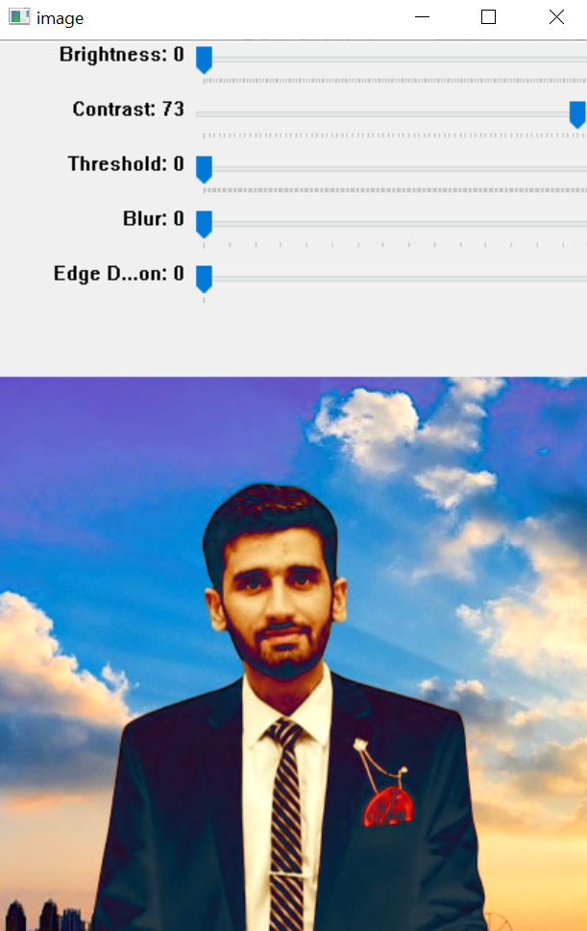

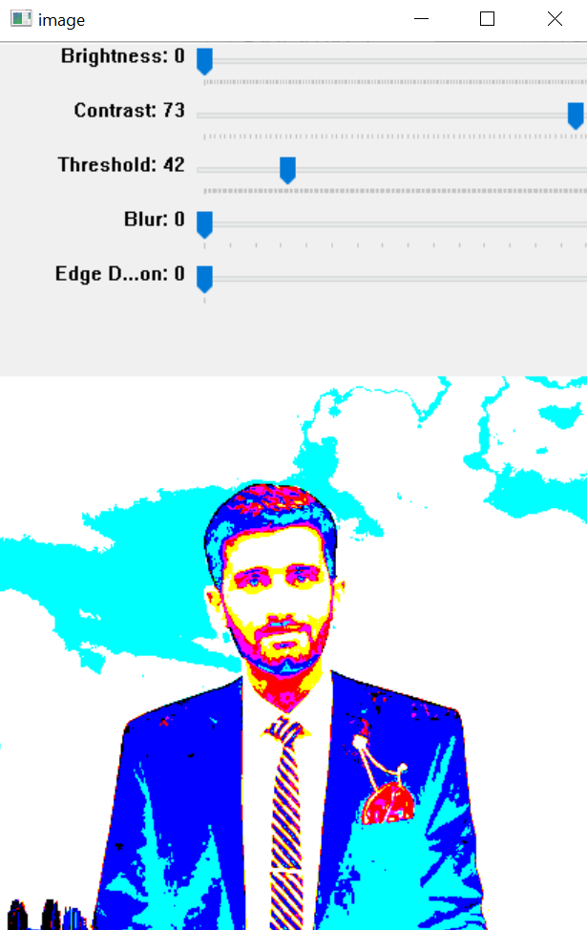

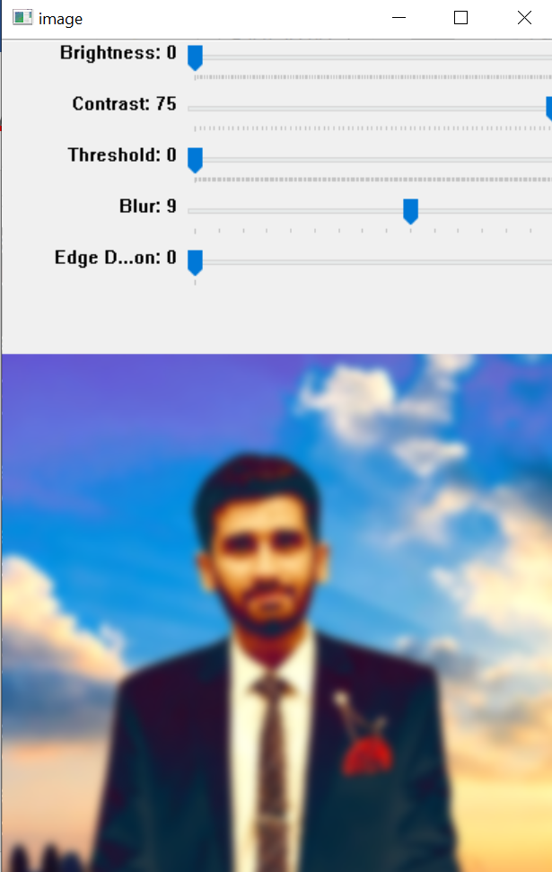

**Q2:P** **roduce black image using python lib and using trackers explore how you can produce R,G,B color on the basis of value from trackbar?**

**Code:**

import cv2

import numpy as np

*# Callback function for trackbar (does nothing but required by createTrackbar)*

def nothing(x):

    pass

*# Create a black image*

img = np.zeros((300, 512, 3), np.uint8)

*# Create a window*

cv2.namedWindow('image')

*# Create trackbars for color change*

cv2.createTrackbar('R', 'image', 0, 255, nothing)

cv2.createTrackbar('G', 'image', 0, 255, nothing)

cv2.createTrackbar('B', 'image', 0, 255, nothing)

while True:

*# Get the current positions of the trackbars*

    r = cv2.getTrackbarPos('R', 'image')

    g = cv2.getTrackbarPos('G', 'image')

    b = cv2.getTrackbarPos('B', 'image')

*# Update the image color*

    img[:] = [b, g, r]

*# Display the image*

    cv2.imshow('image', img)

*# Break the loop when 'ESC' key is pressed*

    if cv2.waitKey(1) & 0xFF == 27:  *# 27 is the ASCII code for the ESC key*

        break

*# Destroy all windows*

cv2.destroyAllWindows()

**OUTPUT:**

**R:**

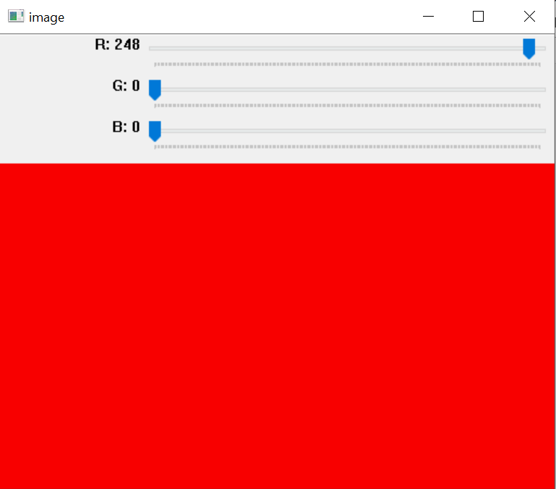

**G:**

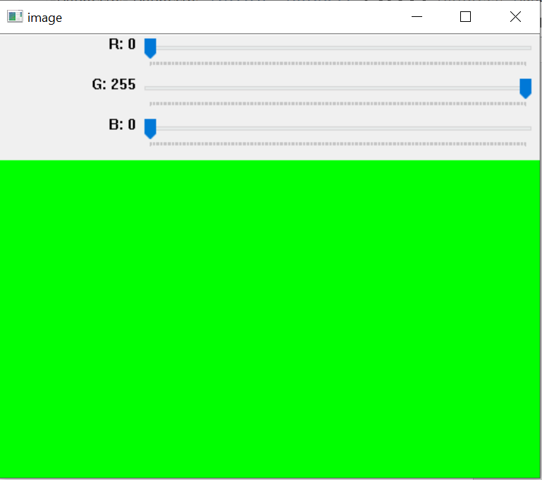

**B:**

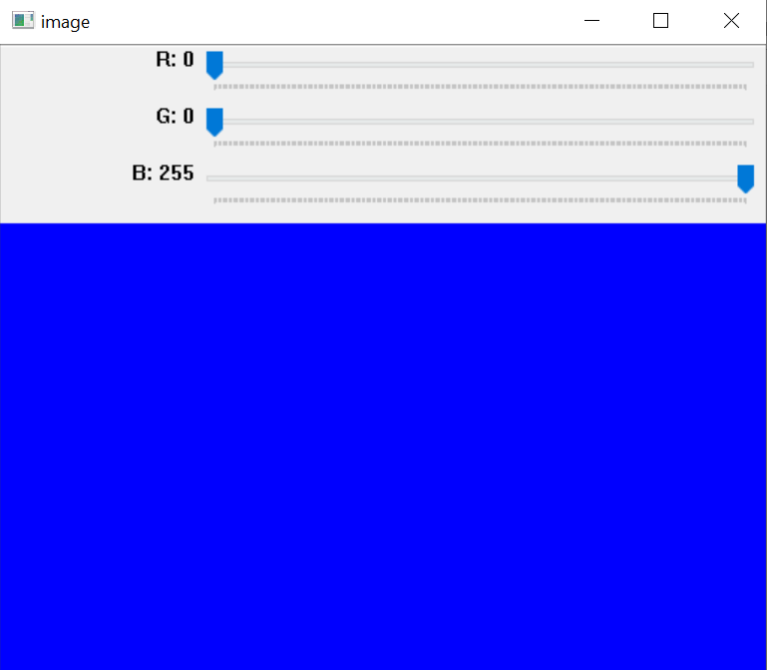

**RGB Mixture:**

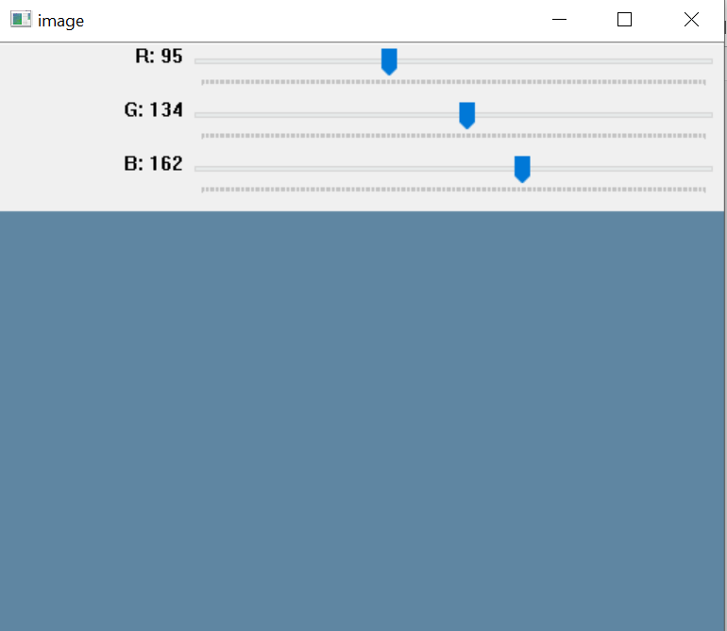

**Q3:Try to draw the block diagram of your dip lab project and identify the core block of it and implement only that using python programming language?**

Code:

//Virtulal painter:

import cv2

import numpy as np

import os

import mediapipe as mp

folderPath = "assets"

myList = os.listdir(folderPath)

overLayList = []

for imPath in myList:

    image = cv2.imread(f'{folderPath}/{imPath}')

    overLayList.append(image)

header = overLayList[0]

brushThickness = 15

eraserThickness = 50

drawColor = (255, 255, 255)

cap = cv2.VideoCapture(1)

cap.set(3, 1280)

cap.set(4, 1280)

initHand = mp.solutions.hands

mainHand = initHand.Hands()

draw = mp.solutions.drawing_utils

def handLandmarks(colorImg):

    landmarkList = []

    landmarkPositions = mainHand.process(colorImg)

    landmarkChek = landmarkPositions.multi_hand_landmarks

    if landmarkChek:

        for hand in landmarkChek:

            for index, landmark in enumerate(hand.landmark):  *# Change here*

                draw.draw_landmarks(img, hand, initHand.HAND_CONNECTIONS)

                landmarkList.append([index, int(landmark.x*1280), int(landmark.y*720)])

    return landmarkList

imgCanvas = np.zeros((720, 1280, 3), np.uint8)

xp, yp = 0, 0

while True:

    success, img = cap.read()

*# Find Hand Landmarks*

    finger_landmarks = handLandmarks(img)

*# Chack which fingers are up*

    if finger_landmarks:

*# Tip of index finger*

        x1, y1 = finger_landmarks[8][1:]

*# Tip of middle finger*

        x2, y2 = finger_landmarks[12][1:]

*# If selection mode "2 fingers are up"*

        if finger_landmarks[8][2] < finger_landmarks[7][2] and finger_landmarks[12][2] < finger_landmarks[11][2]:

            cv2.rectangle(img, (x1, y1-25), (x2, y2+25), drawColor, cv2.FILLED)

            xp, yp = 0, 0

            if y1 < 125:

                if 900 < x1 < 1020:

*# blue*

                    header = overLayList[4]

                    drawColor = (230, 158, 63)

                if 700 < x1 < 800:

*# black*

                    header = overLayList[3]

                    drawColor = (51, 51, 51)

                if 500 < x1 < 600:

*# green*

                    header = overLayList[2]

                    drawColor = (114, 255, 193)

                if 300 < x1 < 400:

*# eraser*

                    header = overLayList[1]

                    drawColor = (0, 0, 0)

                if x1 < 200:

                    imgCanvas = np.zeros((720, 1280, 3), np.uint8)

*# If the drawing mode "index finger is up"*

        if finger_landmarks[8][2] < finger_landmarks[7][2] and finger_landmarks[12][2] > finger_landmarks[11][2]:

            cv2.circle(img, (x1, y1), 15, drawColor, cv2.FILLED)

            if xp == 0 and yp == 0:

                xp, yp = x1, y1

            if drawColor == (0, 0, 0):

                cv2.line(img, (xp, yp), (x1, y1), drawColor, eraserThickness)

                cv2.line(imgCanvas, (xp, yp), (x1, y1), drawColor, eraserThickness)

            elif drawColor != (255, 255, 255):

                cv2.line(img, (xp, yp), (x1, y1), drawColor, brushThickness)

                cv2.line(imgCanvas, (xp, yp), (x1, y1), drawColor, brushThickness)

            xp, yp = x1, y1

    imgGray = cv2.cvtColor(imgCanvas, cv2.COLOR_BGR2GRAY)

    _, imgInv = cv2.threshold(imgGray, 50, 255, cv2.THRESH_BINARY_INV)

    imgInv = cv2.cvtColor(imgInv, cv2.COLOR_GRAY2BGR)

    img = cv2.bitwise_and(img, imgInv)

    img = cv2.bitwise_or(img, imgCanvas)

*# Flip the frame and setting the header image*

    img = cv2.flip(img, 1)

    img[0:125, 0:1280] = header

    cv2.imshow("Virtual Painter", img)

    if cv2.waitKey(1) & 0xFF == ord('q'):

        break

cap.release()

cv2.destroyAllWindows()

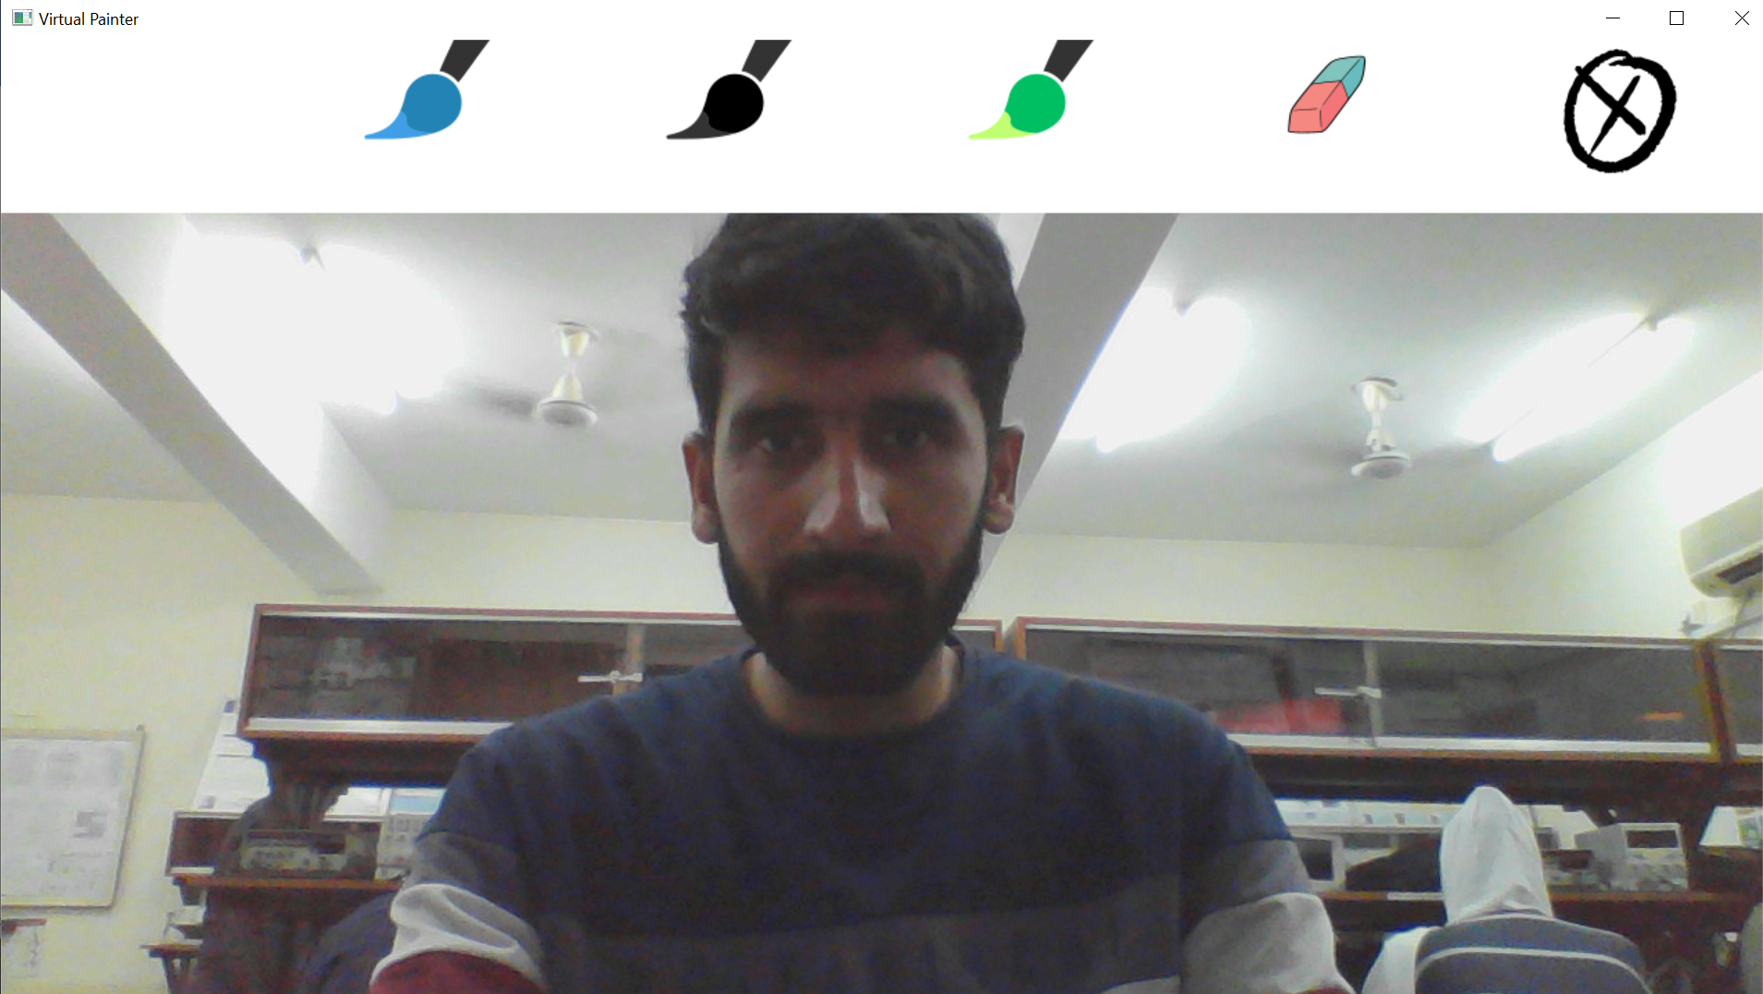

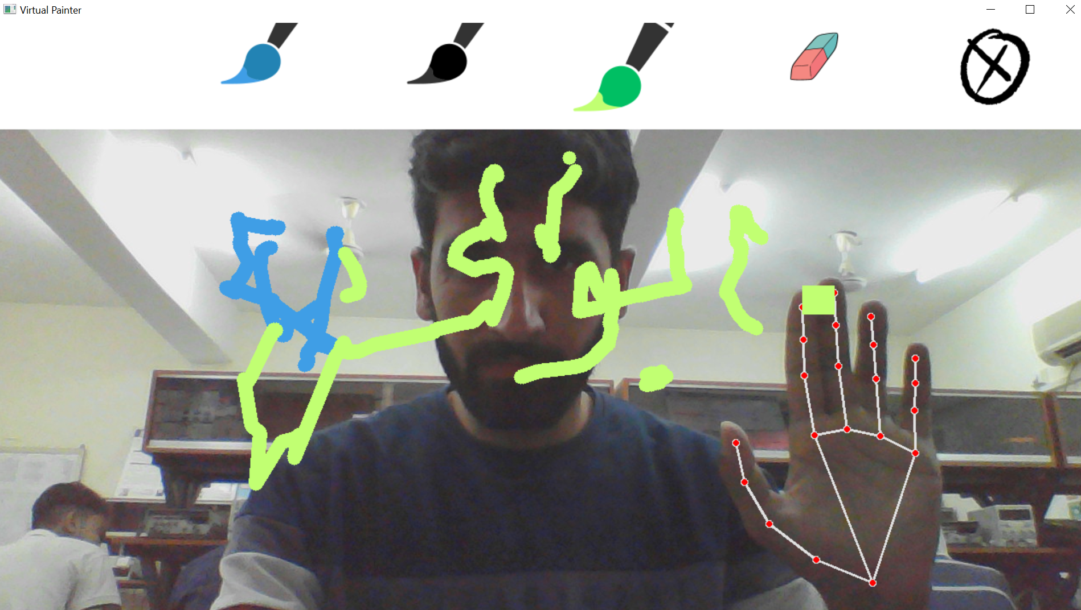

**Block diagram:**

